

**ASSIGNMENT 4**

[Design of a combinational logic circuit using 2 input NAND gates for

1. **4X1 MULTIPLEXER**
2. **1X4 DEMULTIPLEXER**]



**NAME: ROHIT SADHU**

**ROLL NO.: 002010501074**



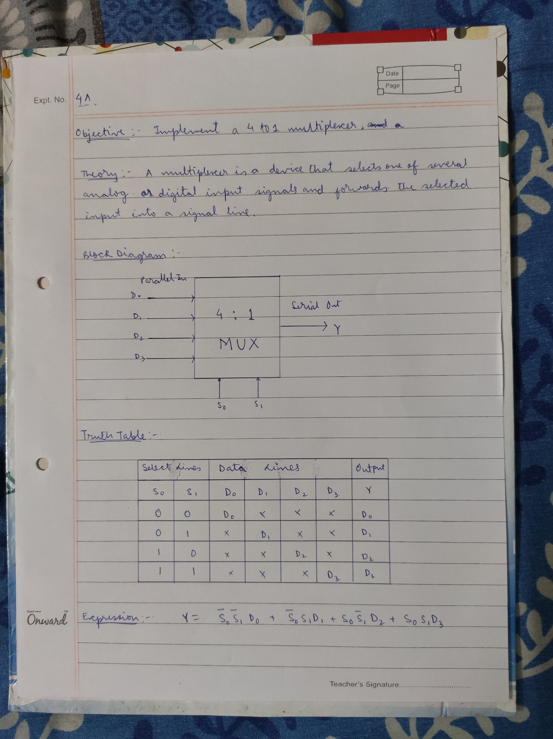

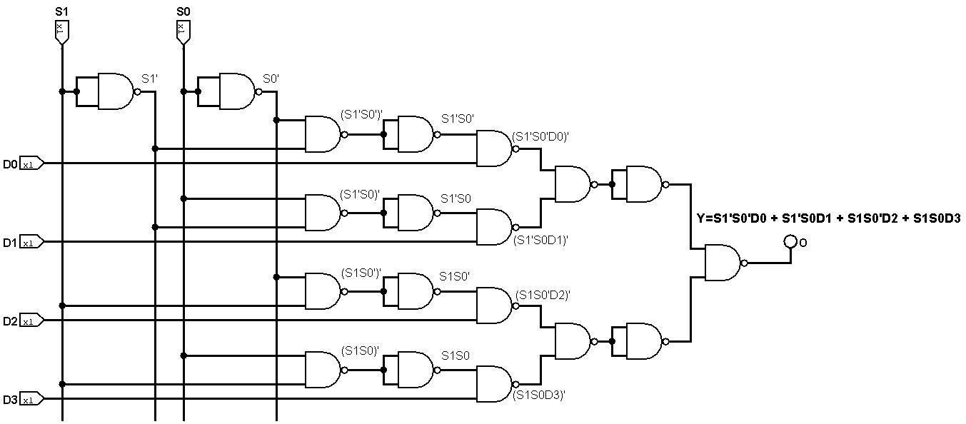**CIRCUIT DIAGRAM: -**

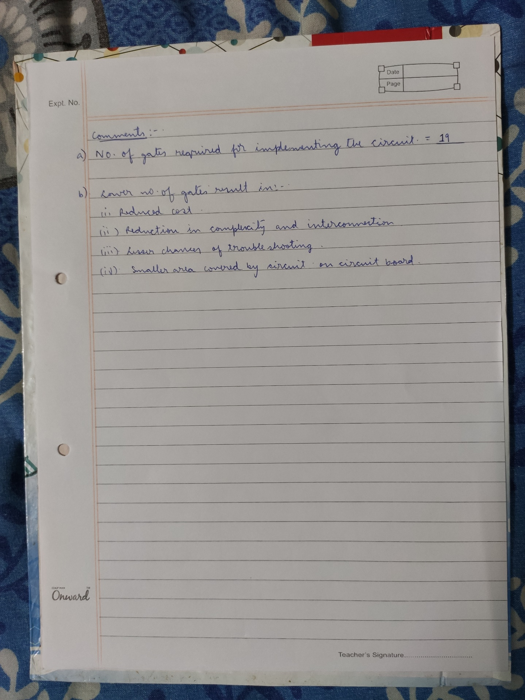

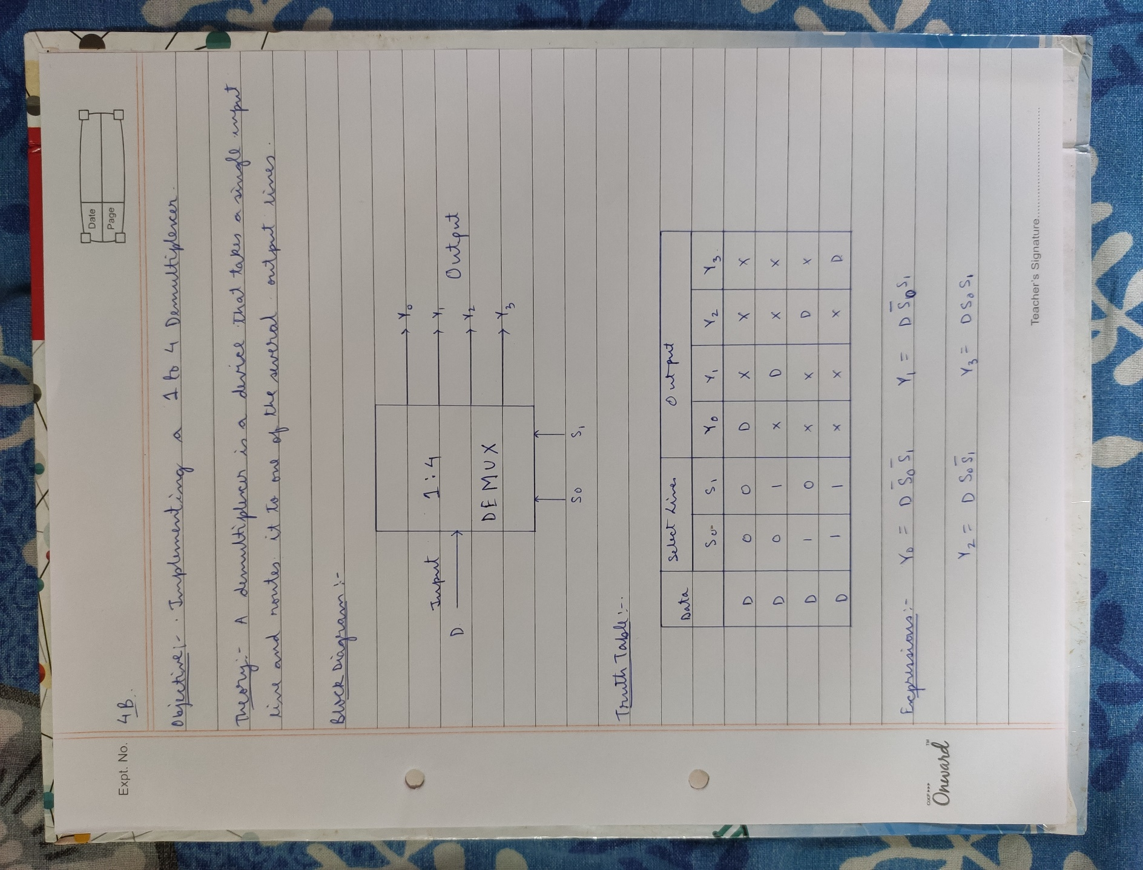

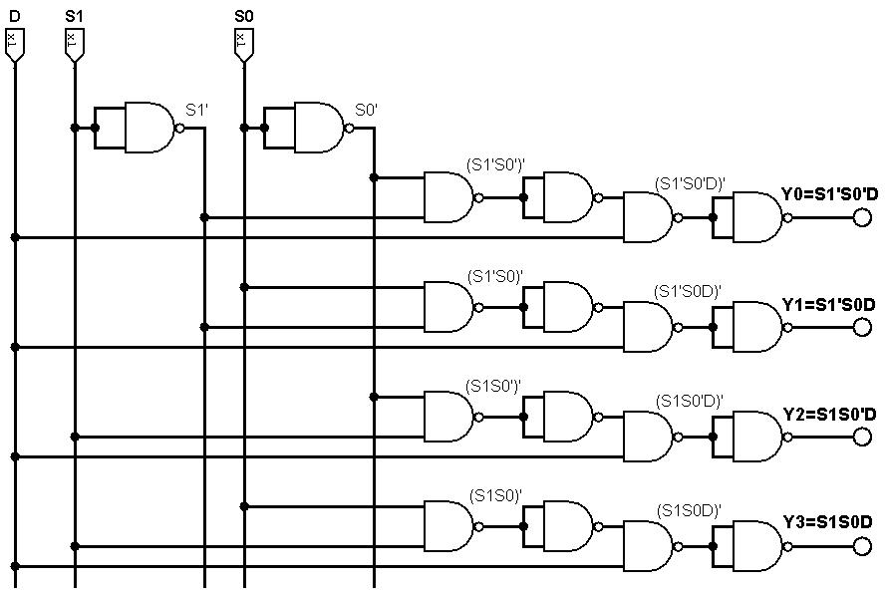**CIRCUIT DIAGRAM: -**

